EXP- 13 NB-IoT vs LTE-M Throughput Simulation

AIM: To compare the throughput performance of NB-IoT and LTE-M technologies by analyzing how throughput varies with SNR and bandwidth using Shannon capacity–based simulation.

APPARATUS REQUIRED
1.MATLAB / Octave software (with Signal Processing and Plotting tools)
2.Computer or Laptop with minimum 4 GB RAM
3.Simulation script for Array Factor analysis
4.Graph plotting utilities (built into MATLAB)
5.Documentation tools (MS Word for tabulation of results and screenshots

THEORY:

NB-IoT and LTE-M are low-power wide-area (LPWA) technologies used in 4G/5G IoT networks.

NB-IoT

Bandwidth: 180 kHz

High coverage, low power

Higher latency → lower throughput

LTE-M

Bandwidth: 1.4 MHz

Lower latency

Supports higher throughput and mobility

Using Shannon capacity:

$$C=B{log⁡}_{2}(1+\text{SNR})$$

Latency is included by scaling the effective throughput:

$$T=\frac{C}{\text{latency}}$$PROCEDURE
- Define bandwidth and latency for NB-IoT and LTE-M.
- Choose an SNR range from 0 to 30 dB.
- Compute throughput vs SNR for each technology using the Shannon formula.
- Plot throughput (in kbps) versus SNR for both systems.
- Fix SNR = 20 dB and calculate throughput vs bandwidth.
- Plot a bar graph comparing NB-IoT and LTE-M throughput at 20 dB SNR.
CODE:
clear; clc; close all;

%% PARAMETERS
BW = [180e3, 1.4e6]; % Bandwidth: NB-IoT, LTE-M (Hz)
latency = [1, 0.1]; % Latency in seconds (NB-IoT, LTE-M)
SNR_dB = 0:5:30; % SNR range in dB
tech = {'NB-IoT','LTE-M'}; % Technology names

%% Throughput vs SNR
throughput = zeros(length(BW), length(SNR_dB));

for t = 1:length(BW)
for s = 1:length(SNR_dB)
snr_linear = 10^(SNR_dB(s)/10);
C = BW(t) * log2(1 + snr_linear); % Shannon capacity
throughput(t,s) = C * (1/latency(t)); % Adjust for latency
end
end

% Plot Throughput vs SNR
figure; hold on;
colors = {'b','r'};
for t = 1:length(BW)
plot(SNR_dB, throughput(t,:)/1e3, 'LineWidth',2,'Color',colors{t}); % kbps
text(SNR_dB(end)+0.5, throughput(t,end)/1e3, tech{t}, 'Color',colors{t}, ...
'FontWeight','bold','FontSize',10);
end
grid on;
xlabel('SNR (dB)');
ylabel('Throughput (kbps)');
title('NB-IoT vs LTE-M Throughput vs SNR');

%% Throughput vs Bandwidth at Fixed SNR
fixed_SNR_dB = 20; % Example SNR
throughput_bw = zeros(length(BW),1);

for t = 1:length(BW)
snr_linear = 10^(fixed_SNR_dB/10);
C = BW(t) * log2(1 + snr_linear);
throughput_bw(t) = C * (1/latency(t));
end

% Plot Throughput vs Bandwidth
figure;
bar(throughput_bw/1e3); % kbps
set(gca,'XTickLabel',tech,'FontWeight','bold');
ylabel('Throughput (kbps)');
title(['Throughput vs Bandwidth at SNR = ' num2str(fixed_SNR_dB) ' dB']);
grid on;

OUTPUTS:
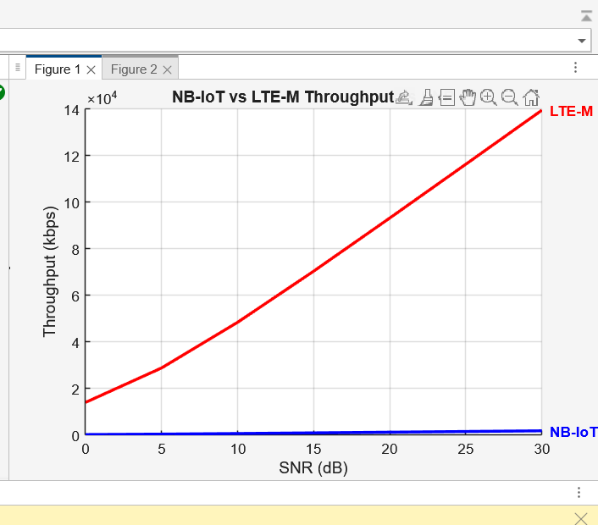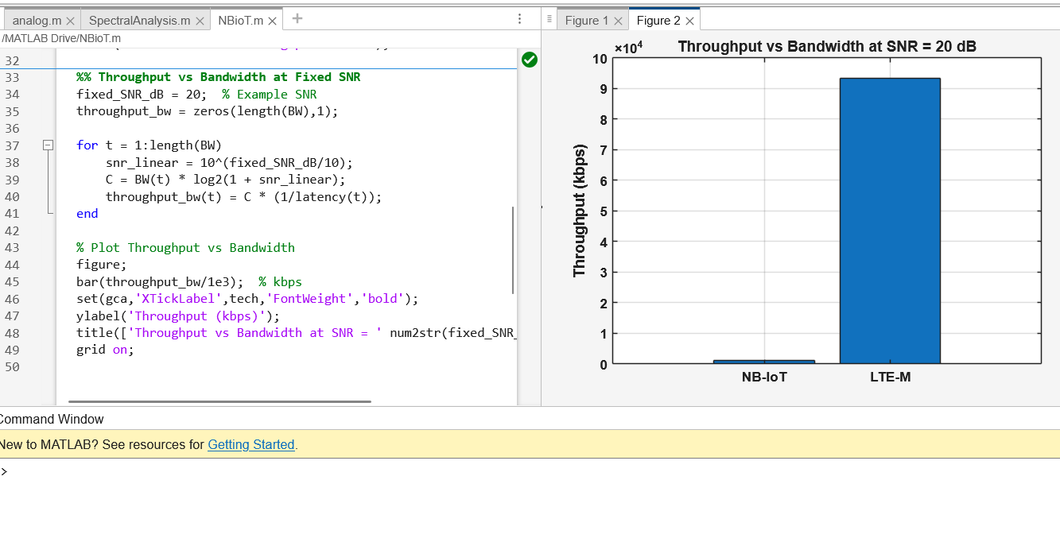

RESULTS:
The analysis confirms that NB-IoT is optimized for low-data-rate, long-coverage IoT applications, while LTE-M supports higher throughput and mobility. Throughput improves with SNR for both systems, but LTE-M outperforms NB-IoT due to its wider bandwidth and faster latency characteristics.

